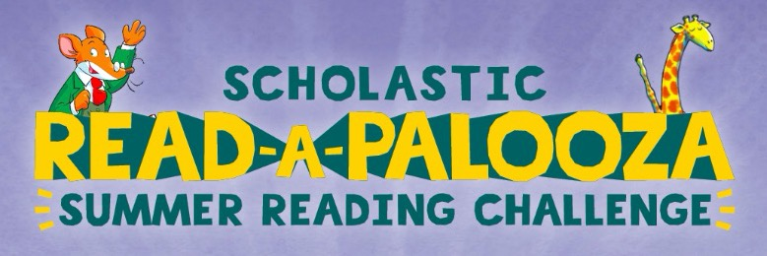

Greetings!
I am happy to inform you that our Richey Elementary Tigers can log their reading steps (minutes) online this summer! They will use the Scholastic Summer Reading app on their MyPascoConnect to do this. On the app they can watch a video of an author read aloud, use a timer, track their minutes read, and earn cool badges!
Happy reading!

